A000-Afr-Benin-Nigeria-Trophy Head-Bronze-Early 20th c

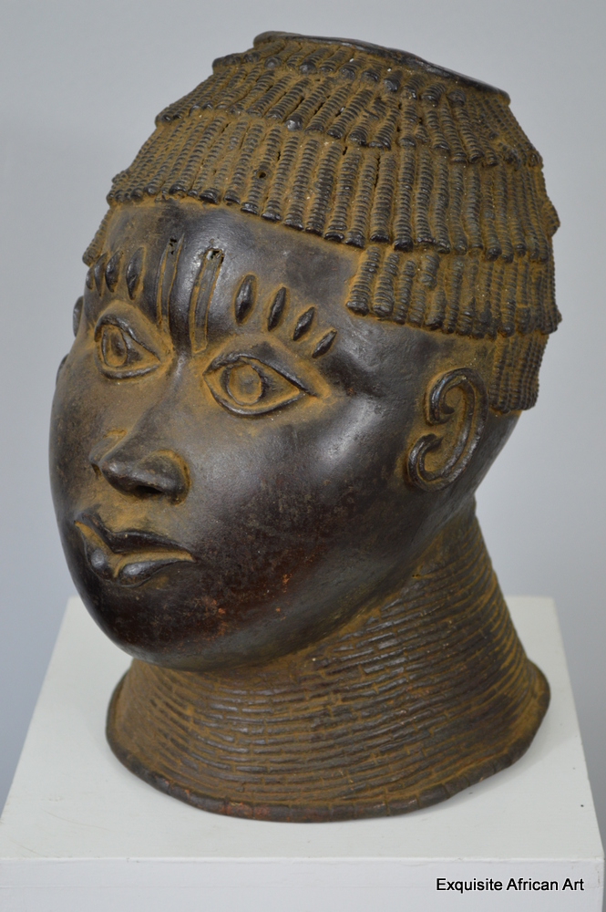

**Case No.: 6**

**Accession No.**

**Formal Label:** Benin bronze trophy head

**Display Description:**

The vast majority of Benin’s artworks are designed to honor the achievements and/or memory of the Obas, the divine rulers of the Benin polities. Until the late 19th century, the Benin centers were a ruling power in Nigeria, dominating trade routes and amassing enormous wealth as the military and economic leaders of their ancient empire. This changed with the appearance of the British forces, which coveted the wealth of the royal palaces and found a series of excuses to mount a punitive expedition against the Oba’s forces in 1897. It was only at this point, the moment of its destruction, that the true achievements of the Benin polities became apparent to western scholars.

Stylistically, the Benin heads follow certain conventions through time, but as metal does not lend itself to radiometric testing it is hard to be sure as to precise dates. The typology currently in acceptance is likely to be overturned as others have been. The piece in question is a magnificently formed and executed casting of a youthful, well-nourished male. The hair is in fact a beaded crown that is cut to the temples across the forehead, then dips once to the level of the ears. It is comprised of bands of overlapping beadwork in the rear, and bands at the front. The apex of the head is missing, to allow the introduction of an elephant tusk. The forehead is prominent, acting as a shelf over the eyes, and decorated with a central double scar indentation and four scarifications over each eye. The eyes are unobscured, large pointed ovals distinct peripheral rims and distinct irises that were originally inlaid with iron. At the lateral apex of each they have a trefoil linear design picked out in relief. The nose is long and elegant, with a broad trilobate end. The lips are fine, yet full and well-formed with a naturalistic fovea above the top lip. The rounded chin hints at the prosperity that the dead Oba doubtless enjoyed through his life. The ears are portrayed as delicate swirls in a faintly molluscan format, and the entire head sits upon a series of twenty one fine, sectorial neck rings that do not extend up onto the face.

The head summons up the traditional issue of the relationship between the Benin and Yoruba polities, for the elongated triple “whiskers” joining the lateral aspects of the mouth to the ears are not often found on Benin pieces. While the Oba has traditionally been associated with the leopard, this was more likely to be expressed as zoomorphic designs and artefacts rather than feline lycanthropy such as this. The Yoruba, however, did use this motif. This is therefore a fascinating object from historical, social and artistic perspectives. The importance of the Benin polity to the development of African and even world art cannot be overestimated.

**Accession Number:**

**LC Classification:**

**Date or Time Horizon:** early 20th c

**Geographical Area:** Nigeria

**Map:**

**GPS coordinates:**

**Cultural Affiliation:** Benin

**Medium:** bronze

**Dimensions:** cm: 31 tall x 19 wide x 24 depth

**Weight:** 4.2kg

**Condition:**

**Provenance:** Ref. Number: 0351 This piece was part of a very large old collection of African art from a sadly now deceased collector from Antwerp in Belgium. £1250.00

**Discussion:**

**References:**

Origin: Nigeria

Approx Age: Early 20th Century

Materials: Bronze

Dimensions cm: 31 tall x 19 wide x 24 depth x

Tribe: Benin

A stunning Benin bronze trophy head, this has been made using the old wax method and very well done. This is a piece that has real presence measuring 31cm tall and weighing 4.2kg. The finer detail is fantastic, on the inside of the head there is visible corrosion, the high neck collar represents coral beads, but the coral cap worn by Oba’s is not present.